Big Mountain Resort – Ticket Price Modeling Report
Problem Statement
Big Mountain Resort is a large ski destination in Montana with 350,000 annual visitors, 105 trails, and 11 lifts, plus a new chair lift recently added to improve visitor distribution. The installation increased operating costs by $1.54M. The resort’s current pricing approach charging a premium above the market average does not accurately capture customer-perceived value or fully leverage the resort’s assets. Management has asked for a data-driven ticket pricing model to guide pricing and investment strategy.
Data Wrangling
- Dataset: 330 U.S. ski resorts, 27 features (numeric, categorical, ticket prices).
- Cleaning:
  - Dropped rows missing both weekday and weekend prices (reduced to 277 resorts).
  - Corrected outliers (e.g., Silverton skiable terrain, yearsOpen=2019).
  - Retained categorical uniqueness (38 regions, 35 states).
Target Variable: AdultWeekend price chosen for modeling (consistent and widely available).
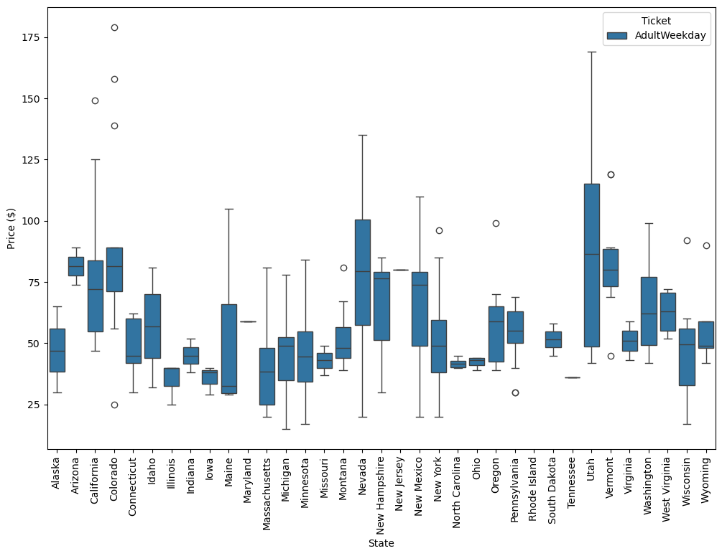
Figure 1: Distribution of AdultWeekend ticket prices across state.

Exploratory Data Analysis (EDA)
- Key Correlations:
  - Strong positive correlation: vertical drop, fastQuads, runs, total chairs, snowmaking.
  - Snowmaking more predictive of price than raw skiable terrain.
  - Night skiing share associated with higher prices.
- Geographic Insights:
  - States with many resorts → competitive pricing.
  - States with few resorts → monopoly-driven higher pricing.
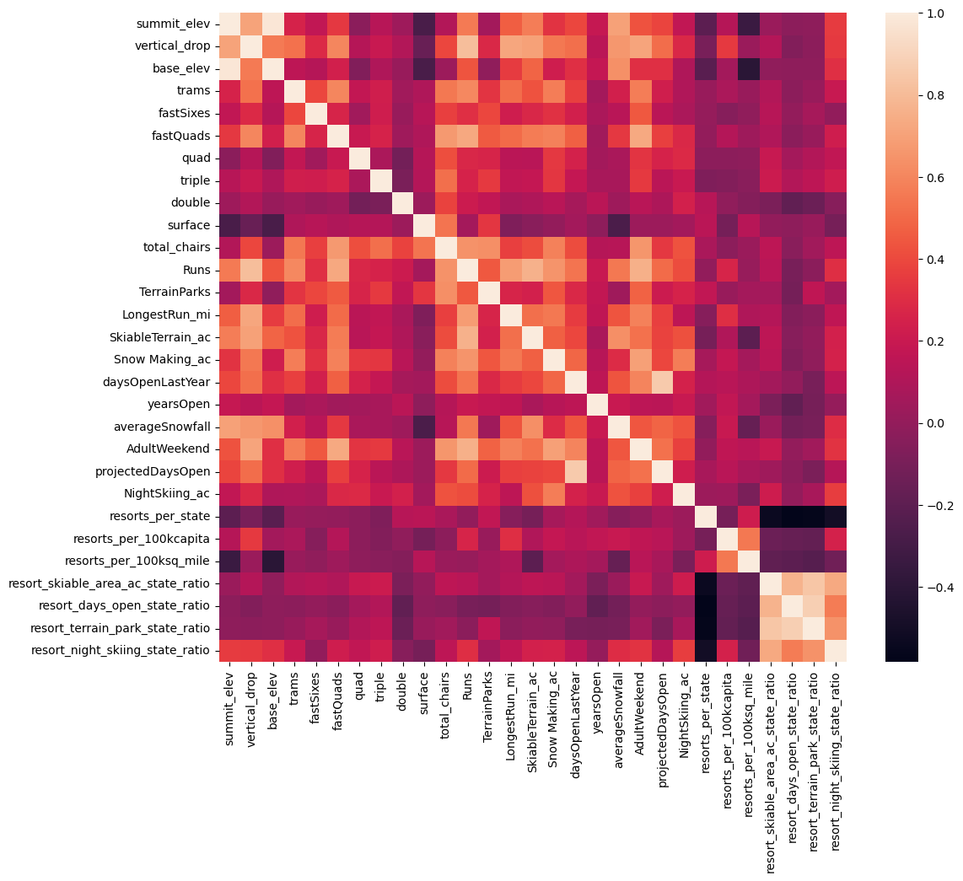
Figure 2: Heatmap of feature correlations with ticket price.

Model Preprocessing & Feature Engineering
- Preprocessing:
  - Median imputation for missing values.
  - Scaling for linear models.
  - SelectKBest for feature selection.
- Engineered Features:
  - Ratios: chairs-to-runs, chairs-to-skiable area, state-relative features.
  - Helped capture competitive vs. exclusive market dynamics.
Algorithms & Evaluation Metrics
- Baseline: Mean predictor → MAE ≈ $19.
- Linear Regression:
  - CV MAE ≈ $10.5; Test MAE ≈ $11.8.
  - Top features: vertical drop, snowmaking, fastQuads, runs.
- Random Forest:
  - CV MAE ≈ $9.6; Test MAE ≈ $9.5.
  - More accurate and stable than linear regression.
- Metric Used: Mean Absolute Error (MAE) for interpretability in dollars.
Winning Model & Scenario Modeling
- Final Model: Random Forest chosen for accuracy, stability, and ability to capture nonlinear feature interactions.
- Big Mountain Insights:
  - Current weekday ticket price = $81.00.
  - Modeled market-supported price = $95.87.
  - Suggests underpricing by ~$15.
Scenarios:
- Closing runs:
  - Closing ≤3 runs → negligible price impact.
  - Closing >6 runs → ~$1.50 drop in supported price.
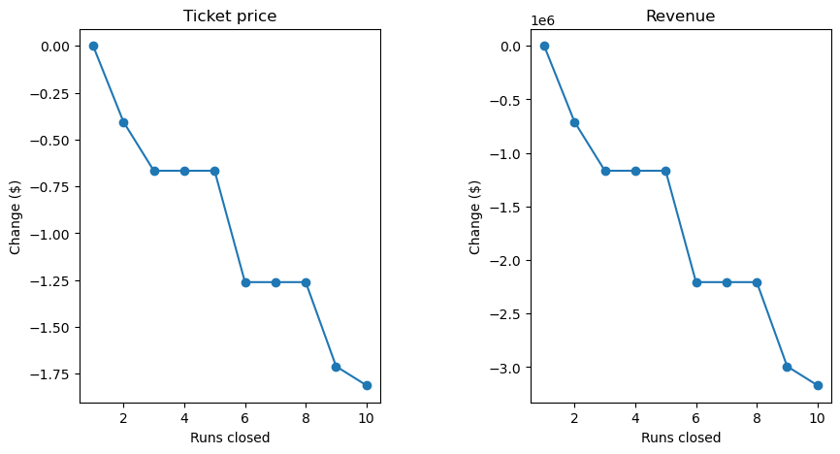
Figure 3: Predicted ticket price vs. number of closed runs.
- Adding 1 run + vertical drop + chair lift:
  - Ticket price ↑ $1.99.
  - Projected seasonal revenue gain: ~$3.5M (assuming 5 tickets/visitor).
Figure 6: Predicted revenue impact of adding run + lift.
- Small snowmaking or run extensions:
  - No measurable pricing effect at current scale.
Pricing Recommendation
- Near-Term:
  - Big Mountain can support a modest ticket price increase ($2–$5) while remaining competitive.
  - Focus on investments in runs, vertical drop, and lifts, which drive higher pricing power.
- Operational Strategy:
  - Close only underutilized runs; monitor visitor response.
  - Test price adjustments incrementally before scaling.
Conclusion
- Big Mountain is undervaluing its tickets relative to market-supported price (~$96).
- Strategic feature additions (runs, lifts, vertical drop) unlock measurable pricing power.
- Small improvements (snowmaking, marginal run extensions) show minimal impact.
- Recommendation: implement controlled ticket price increases alongside targeted infrastructure investments.

Future Scope of Work
- Integrate operating costs: lift maintenance, snowmaking energy, labor, insurance.
- Include demand-side data: customer demographics, seasonality, and willingness-to-pay surveys.
- Build operational tool: dashboard or web app for scenario testing by business analysts.
- Validate predictions: real-world experiments with run closures or new lift additions.

